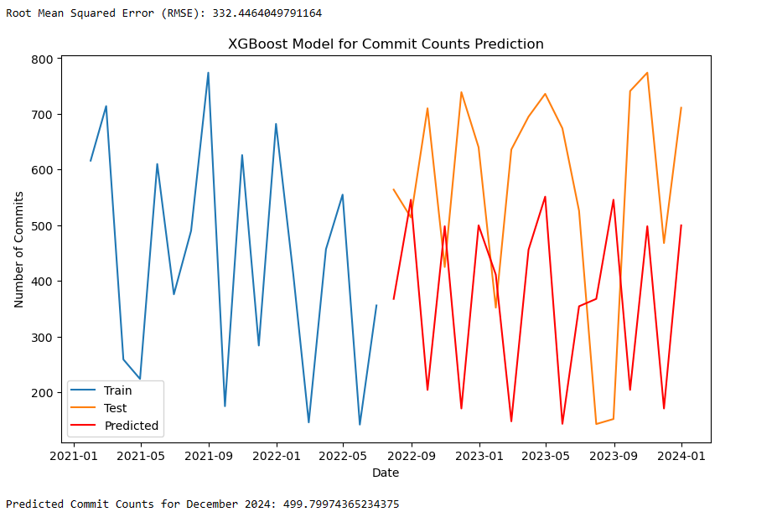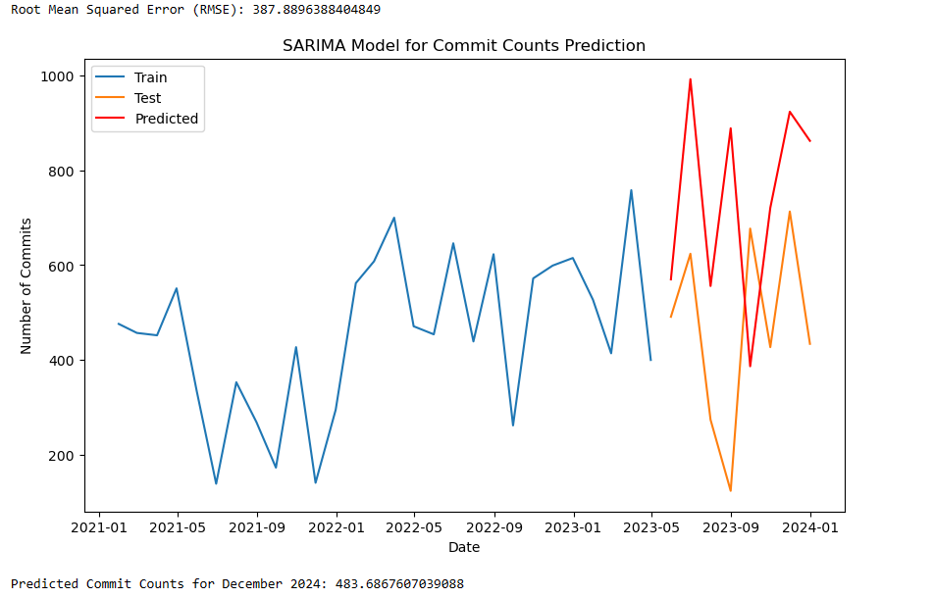

**Explanation:**

Root Mean Squared Error (RMSE) values indicate the accuracy of the model. Lower RMSE values generally indicate better model performance.

**In this case:**

XGBoost Model:

* Prediction: 499.79974365234375
* RMSE: 332.4464049791164

SARIMA Model:

* Prediction: 483.6867607039088
* RMSE: 387.8896388404849

Comparing the RMSE values, the XGBoost model has a lower RMSE (332.45) compared to the SARIMA model (387.89). This suggests that, based on the RMSE metric alone, the XGBoost model provides a more accurate prediction.